## Positional Truth

When you believe in the Lord Jesus Christ, God the Holy Spirit enters you into eternal relationship or union with Jesus Christ. This is your permanent relationship with Christ. You are positionally “in Christ” forever. John 14:20; Acts 16:31.

“"In that day you will know that I am in My Father, and you in Me, and I in you.” (John 14:20, NASB)

“They said, "Believe in the Lord Jesus, and you will be saved, you and your household."” (Acts 16:31, NASB)

Positional Truth produces a new creature in union with Christ. 2 Corinthians 5:17 speaks of this position. As a “new creature” in Christ, the believer is born again whereby God the Holy Spirit also creates a human spirit for the believer. The human spirit enables understanding of Bible doctrine when filled with the Holy Spirit and the ability to fellowship with God. “The old things passed away” refers to spiritual death. “New things have come” refers to spiritual life. See category on [Regeneration](https://atxbiblechurchmedia.github.io/categoricalnotebook/QR/Regeneration.html).

“Therefore if anyone is in Christ, he is a new creature; the old things passed away; behold, new things have come.” (2 Corinthians 5:17, NASB)

You can never lose this union. It’s permanent. Your relationship with Christ is an eternal union. This is the top circle in the diagram below. Rom. 8:35-39.

“Who will separate us from the love of Christ? Will tribulation, or distress, or persecution, or famine, or nakedness, or peril, or sword? Just as it is written, "FOR YOUR SAKE WE ARE BEING PUT TO DEATH ALL DAY LONG; WE WERE CONSIDERED AS SHEEP TO BE SLAUGHTERED." But in all these things we overwhelmingly conquer through Him who loved us. For I am convinced that neither death, nor life, nor angels, nor principalities, nor things present, nor things to come, nor powers, nor height, nor depth, nor any other created thing, will be able to separate us from the love of God, which is in Christ Jesus our Lord.” (Romans 8:35-39, NASB)

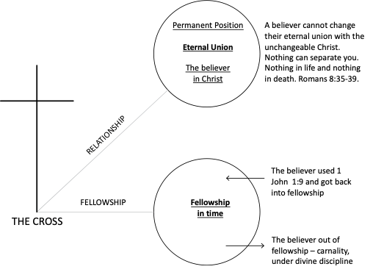

However, you can get out of your fellowship as you live your life, but you cannot get out of your permanent relationship. When you get out of fellowship, you need to use 1 John 1:9 to confess or cite your known sins to God the Father, then your fellowship is restored. This is represented by the bottom circle in the diagram above.

“If we confess our sins, He is faithful and righteous to forgive us our sins and to cleanse us from all unrighteousness.” (1 John 1:9, NASB)

What does it mean to be in union with Christ? Understanding this is very important. This means that Christ shares with us everything He has. Everything Christ is we are. However, we do not take on attributes of His deity or other attributes ascribed to God only.

Jesus Christ is eternal life and His eternal life is imputed to every believer at salvation. Jesus Christ is absolute righteousness. His righteousness is imputed to every believer at salvation. His righteousness becomes your righteousness. Jesus Christ has an eternal destiny. His eternal destiny becomes your destiny.

Jesus Christ was elected by God the Father. His election becomes our election through union with Christ. Jesus Christ is God the Son and co-equal with God the Father. We share this election and we become sons of God. Jesus Christ is a high priest and in Him we become priests. Jesus Christ is a King, and in Him we shall reign with Him.

This is not an exhaustive list, but perhaps Romans 8:17 sums up the great doctrine of positional truth.

"and if children, heirs also, heirs of God and fellow heirs with Christ, if indeed we suffer with Him so that we may also be glorified with Him. " (Romans 8:17, NASB)

**Categories of Positional Truth**

Positional Truth exists in three categories and is illustrated in the diagram below: Retroactive Positional Truth, Current Positional Truth, and Experiential Positional Truth. In Galatians 2:20, “I have been crucified with Christ” refers to Retroactive Positional Truth. “It is no longer I who live” refers to Current Positional Truth whereby we receive God’s eternal life due to belief in the Lord Jesus Christ for salvation resulting in our eternal identification with Christ in His resurrection, ascension, and session. “But Christ lives in me” refers to Experiential Positional Truth which means that you live the life of Christ when you are filled with the Holy Spirit.

““I have been crucified with Christ; and it is no longer I who live, but Christ lives in me; and the life which I now live in the flesh I live by faith in the Son of God, who loved me and gave Himself up for me.”  (Galatians 2:20, NASB)

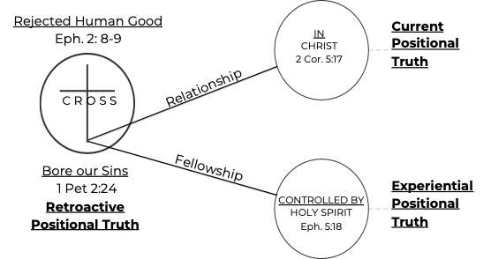

Positional Truth is not an experience. It is not progressive because it was already perfect at the point of salvation. Positional Truth is not related to human merit as it is entirely the grace work of the Holy Spirit. Positional Truth is eternal in nature and known only in the Word of God and obtained entirely at moment of salvation. Rom. 8:38-39.

“For I am convinced that neither death, nor life, nor angels, nor principalities, nor things present, nor things to come, nor powers, nor height, nor depth, nor any other created thing, will be able to separate us from the love of God, which is in Christ Jesus our Lord.” (Romans 8:38-39, NASB)

Every believer has likely had some doubts concerning their salvation at one time or another. The reason is that we did not understand relationship and fellowship. The moment you were saved, 40 things happened. One of them was that God the Holy Spirit entered you into union with Christ. This is called the Baptism of the Holy Spirit. The phrase “in Christ” speaks of the eternal union of a born-again individual. Since you are in union with Christ, there is “no condemnation” and “no separation.” 1 Cor. 12:13; Rom. 8:1, Rom. 8:35. See category on [The 40 Things Received at Salvation](https://atxbiblechurchmedia.github.io/categoricalnotebook/S/The%2040%20Things%20Received%20at%20Salvation.html).

"For by one Spirit we were all baptized into one body, whether Jews or Greeks, whether slaves or free, and we were all made to drink of one Spirit." (1 Corinthians 12:13, NASB)

"Therefore there is now no condemnation for those who are in Christ Jesus." (Romans 8:1, NASB)

"Who will separate us from the love of Christ? Will tribulation, or distress, or persecution, or famine, or nakedness, or peril, or sword?" (Romans 8:35, NASB)

Remember 2 Corinthians 5:17 speaks of our position in Christ. When you believed in the Lord, you became a new creature positionally. You are a new creature because of eternal life and the imputation of God’s absolute righteousness (+R) to every believer. See category on [Justification](https://atxbiblechurchmedia.github.io/categoricalnotebook/J/Justification.html).

"Therefore if anyone is in Christ, he is a new creature; the old things passed away; behold, new things have come." (2 Corinthians 5:17, NASB)

A believer is a new creature because of what Christ did for you, not what you did for Him! Remember, you don’t have to give up anything in order to be saved. The greatest slam to Christ’s saving work on the Cross is to think you can do something to be saved like change your behavior pattern, or sign a card, or join a church, or put money in the offering.

Your life is changed because of His divine power! But we can’t live the Christian life in the power of the flesh. But when we get out of fellowship, we still possess eternal life, we can’t change the Son relationship, we are always sons, we will always be in God’s family from the point of conversion onward.

An incorrect conclusion by some is that as long as I can’t lose my salvation, I can go live it up! You forgot something! God administers divine discipline to correct the believer’s thinking and to remind them to confess their sins biblically and be restored to fellowship with Him. Heb. 12:6; Heb. 12:7-8; 2 Sam. 7:14; Prov. 3:11-12.

"FOR THOSE WHOM THE LORD LOVES HE DISCIPLINES, AND HE SCOURGES EVERY SON WHOM HE RECEIVES."" (Hebrews 12:6, NASB)

"It is for discipline that you endure; God deals with you as with sons; for what son is there whom his father does not discipline? But if you are without discipline, of which all have become partakers, then you are illegitimate children and not sons." (Hebrews 12:7-8, NASB)

""I will be a father to him and he will be a son to Me; when he commits iniquity, I will correct him with the rod of men and the strokes of the sons of men," (2 Samuel 7:14, NASB)

"My son, do not reject the discipline of the LORD Or loathe His reproof, For whom the LORD loves He reproves, Even as a father corrects the son in whom he delights." (Proverbs 3:11-12, NASB)

**The Mechanics and Means of Positional Truth**

Means of Positional Truth is faith in the Lord Jesus Christ. The mechanics of Positional Truth is the work of the Holy Spirit. Positional Truth includes regeneration, a new birth where we receive a human spirit from God the Holy Spirit at the moment of salvation. Acts 16:31; Titus 3:5; John 3:5-6; Eph. 2:1-2; Eph. 2:4-6.

“They said, "Believe in the Lord Jesus, and you will be saved, you and your household."” (Acts 16:31, NASB)

“He saved us, not on the basis of deeds which we have done in righteousness, but according to His mercy, by the washing of regeneration and renewing by the Holy Spirit,” (Titus 3:5, NASB)

“Jesus answered, "Truly, truly, I say to you, unless one is born of water and the Spirit he cannot enter into the kingdom of God. "That which is born of the flesh is flesh, and that which is born of the Spirit is spirit.” (John 3:5-6, NASB)

“And you were dead in your trespasses and sins, in which you formerly walked according to the course of this world, according to the prince of the power of the air, of the spirit that is now working in the sons of disobedience.” (Ephesians 2:1-2, NASB)

“But God, being rich in mercy, because of His great love with which He loved us, even when we were dead in our transgressions, made us alive together with Christ (by grace you have been saved), and raised us up with Him, and seated us with Him in the heavenly places in Christ Jesus,” (Ephesians 2:4-6, NASB)

Positional Truth includes the permanent indwelling of our bodies by the Holy Spirit. 1 Cor. 6:19.

“Or do you not know that your body is a temple of the Holy Spirit who is in you, whom you have from God, and that you are not your own?” (1 Corinthians 6:19, NASB)

Positional Truth includes the sealing of the Holy Spirit. This is our guarantee of eternal security. Eph. 1:13; Eph. 4:30; Rom. 8:38-39; 1 John 5:11-12; John 10:28-29.

“In Him, you also, after listening to the message of truth, the gospel of your salvation—having also believed, you were sealed in Him with the Holy Spirit of promise,” (Ephesians 1:13, NASB)

“Do not grieve the Holy Spirit of God, by whom you were sealed for the day of redemption.” (Ephesians 4:30, NASB)

“For I am convinced that neither death, nor life, nor angels, nor principalities, nor things present, nor things to come, nor powers, nor height, nor depth, nor any other created thing, will be able to separate us from the love of God, which is in Christ Jesus our Lord.” (Romans 8:38-39, NASB)

“And the testimony is this, that God has given us eternal life, and this life is in His Son. He who has the Son has the life; he who does not have the Son of God does not have the life.” (1 John 5:11-12, NASB)

“and I give eternal life to them, and they will never perish; and no one will snatch them out of My hand. "My Father, who has given them to Me, is greater than all; and no one is able to snatch them out of the Father's hand.” (John 10:28-29, NASB)

Positional Truth includes the Baptism of the Holy Spirit where the Holy Spirit places every believer into union with Jesus Christ. 1 Cor. 12:13.

“For by one Spirit we were all baptized into one body, whether Jews or Greeks, whether slaves or free, and we were all made to drink of one Spirit.” (1 Corinthians 12:13, NASB)

Positional Truth includes the Holy Spirit conveying at least one spiritual gift to every Church Age believer. Spiritual gifts are to designed to expand and edify the body of believers - the Body of Christ. 1 Cor. 12:11.

“But one and the same Spirit works all these things, distributing to each one individually just as He wills.” (1 Corinthians 12:11, NASB)

Positional Truth is declared to belong to carnal believers as well as the spiritual believer. 1 Cor. 1:2; 1 Cor. 1:30.

“To the church of God which is at Corinth, to those who have been sanctified in Christ Jesus, saints by calling, with all who in every place call on the name of our Lord Jesus Christ, their Lord and ours:” (1 Corinthians 1:2, NASB)

“But by His doing you are in Christ Jesus, who became to us wisdom from God, and righteousness and sanctification, and redemption,” (1 Corinthians 1:30, NASB)

Positional Truth protects the believer from eternal judgment. The believer in Christ will not be judged for sin because our Lord was already judged on the Cross for all sins of mankind. Rom. 8:1.

“Therefore there is now no condemnation for those who are in Christ Jesus.” (Romans 8:1, NASB)

Positional Truth results in the believer sharing Jesus Christ’s eternal life. 1 John 5:11-12.

“And the testimony is this, that God has given us eternal life, and this life is in His Son. He who has the Son has the life; he who does not have the Son of God does not have the life.” (1 John 5:11-12, NASB)

Positional Truth results in the believer sharing Jesus Christ’s perfect and absolute righteousness (+R). 2 Cor. 5:21.

“He made Him who knew no sin to be sin on our behalf, so that we might become the righteousness of God in Him.” (2 Corinthians 5:21, NASB)

Positional Truth results in the believer sharing Jesus Christ’s Sonship. Gal. 3:26; John 1:12.

“For you are all sons of God through faith in Christ Jesus.” (Galatians 3:26, NASB)

“But as many as received Him, to them He gave the right to become children of God, even to those who believe in His name,” (John 1:12, NASB)

Positional Truth results in the believer sharing Jesus Christ’s Heirship. Rom. 8:16-17.

“The Spirit Himself testifies with our spirit that we are children of God, and if children, heirs also, heirs of God and fellow heirs with Christ, if indeed we suffer with Him so that we may also be glorified with Him.” (Romans 8:16-17, NASB)

Positional Truth results in the believer sharing Jesus Christ’s election. Jesus Christ is elected, so everyone in union with Christ shares His election. Eph. 1:4; 1 Peter 1:2.

“just as He chose us in Him before the foundation of the world, that we would be holy and blameless before Him. In love” (Ephesians 1:4, NASB)

“according to the foreknowledge of God the Father, by the sanctifying work of the Spirit, to obey Jesus Christ and be sprinkled with His blood: May grace and peace be yours in the fullest measure.” (1 Peter 1:2, NASB)

Positional Truth results in the believer sharing Jesus Christ’s destiny. Jesus Christ has an eternal destiny. In union with Christ, the believer shares His eternal destiny. Isaiah 45:1; 1 Peter 2:6; Eph. 1:5; Eph. 1:11.

“Thus says the LORD to Cyrus His anointed, Whom I have taken by the right hand, To subdue nations before him And to loose the loins of kings; To open doors before him so that gates will not be shut:” (Isaiah 45:1, NASB)

“For this is contained in Scripture: "BEHOLD, I LAY IN ZION A CHOICE STONE, A PRECIOUS CORNER stone, AND HE WHO BELIEVES IN HIM WILL NOT BE DISAPPOINTED."” (1 Peter 2:6, NASB)

“He predestined us to adoption as sons through Jesus Christ to Himself, according to the kind intention of His will,” (Ephesians 1:5, NASB)

“also we have obtained an inheritance, having been predestined according to His purpose who works all things after the counsel of His will,” (Ephesians 1:11, NASB)

Positional Truth results in the believer sharing Jesus Christ’s Kingship. 2 Peter 1:11; 1 Thess. 2:12; Rev. 1:6.

“for in this way the entrance into the eternal kingdom of our Lord and Savior Jesus Christ will be abundantly supplied to you.” (2 Peter 1:11, NASB)

“so that you would walk in a manner worthy of the God who calls you into His own kingdom and glory.” (1 Thessalonians 2:12, NASB)

“and He has made us to be a kingdom, priests to His God and Father—to Him be the glory and the dominion forever and ever. Amen.” (Revelation 1:6, NASB)

Positional Truth results in the believer sharing Jesus Christ’s priesthood where we have the privilege of worship, giving, prayer, and praise. 1 Peter 2:5; 1 Peter 2:9.

“you also, as living stones, are being built up as a spiritual house for a holy priesthood, to offer up spiritual sacrifices acceptable to God through Jesus Christ.” (1 Peter 2:5, NASB)

“But you are A CHOSEN RACE, A royal PRIESTHOOD, A HOLY NATION, A PEOPLE FOR God's OWN POSSESSION, so that you may proclaim the excellencies of Him who has called you out of darkness into His marvelous light;” (1 Peter 2:9, NASB)

Positional Truth results in the believer sharing Jesus Christ’s sanctification. Believers are accepted “in the Beloved.” 1 Cor. 1:2; Eph. 1:6.

“To the church of God which is at Corinth, to those who have been sanctified in Christ Jesus, saints by calling, with all who in every place call on the name of our Lord Jesus Christ, their Lord and ours:” (1 Corinthians 1:2, NASB)

“to the praise of the glory of His grace, which He freely bestowed on us in the Beloved.” (Ephesians 1:6, NASB)

**Experiential Positional Truth**

Experiential Positional Truth or Temporal Fellowship is illustrated in the diagram above as the “Bottom Circle.” At the moment of salvation, every Church Age believer’s soul is filled with the Holy Spirit where the Holy Spirit controls the soul. Spirituality is an absolute status. Your soul is either 100% controlled by the Spirit (in fellowship with God) or 100% controlled by your old sin nature. There is no such thing as partial spirituality because God cannot reside in the same place as sin.

The believer is always either in a state of spirituality of carnality. You are either in fellowship with God or out of fellowship with God. There is no nothing in between. You are either walking in the Spirit (spiritual) or walking in the flesh (carnal).

You are either walking in the light (fellowship) or walking in darkness (carnality). You are either producing divine good (must be filled with the Holy Spirit) or you are producing human good from your own human abilities while your soul is controlled by your old sin nature (the flesh).

Every believer loses the filling of the Holy Spirit by sinning. The believer sins by an act of negative volition toward control of the Holy Spirit. 1 John 1:8; 1 John 1:10.

“If we say that we have no sin, we are deceiving ourselves and the truth is not in us.” (1 John 1:8, NASB)

“If we say that we have not sinned, we make Him a liar and His word is not in us.” (1 John 1:10, NASB)

There is only one way to recover the filling of the Holy Spirit - by confession of sin biblically by simply acknowledging, naming, or citing your known sins directly to God the Father. The believer is simply naming or identifying a sin that has already been judged. 1 John 1:9.

“If we confess our sins, He is faithful and righteous to forgive us our sins and to cleanse us from all unrighteousness.” (1 John 1:9, NASB)

We are commanded to keep on being filled with (controlled by) the Holy Spirit. Eph. 5:18.

“And do not get drunk with wine, for that is dissipation, but be filled with the Spirit,” (Ephesians 5:18, NASB)

The critical issue is who controls your life? The Holy Spirit or your old sin nature? The believer out of fellowship is subject to divine discipline intended to change the carnal believer’s thinking so they will decide to return to fellowship with God.

**Comparison of Eternal Fellowship and Temporal Fellowship**

The table below provides many of the differences between the eternal fellowship all believers have in union with Jesus Christ and the temporal fellowship all believers can have when their souls are filled with the Holy Spirit.

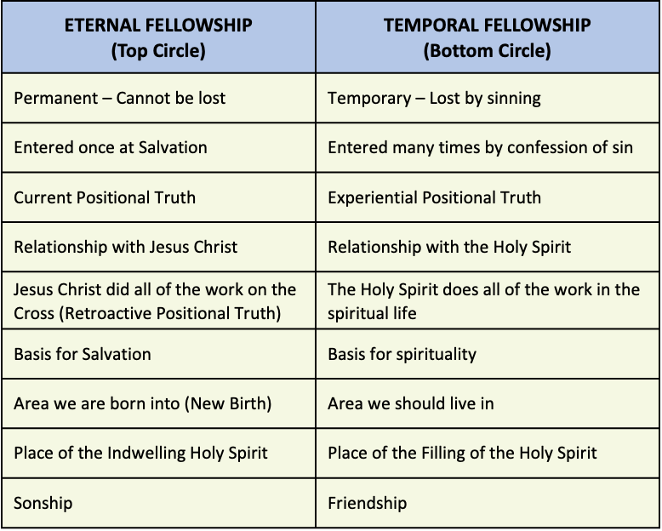

**The Believer’s Soul - Either Controlled by the Holy Spirit or the Old Sin Nature**

The Filling of the Holy Spirit

Temporal Fellowship depends entirely on filling of the Holy Spirit who empowers the believer’s spiritual life. When the believer is filled with the Holy Spirit, the soul is controlled by the Holy Spirit and they are said to be in fellowship with God. When the believer is filled with the Holy Spirit, the character of Christ is produced in them as they mature spiritually. Gal. 5:22-23.

“But the fruit of the Spirit is love, joy, peace, patience, kindness, goodness, faithfulness, gentleness, self-control; against such things there is no law.” (Galatians 5:22-23, NASB)

When the believer is filled with the Holy Spirit, the perception of Bible doctrine is possible. 1 Cor. 2:13. See category on the [Grace Apparatus For Perception](https://atxbiblechurchmedia.github.io/categoricalnotebook/G/Grace%20Apparatus%20For%20Perception.html).

“which things we also speak, not in words taught by human wisdom, but in those taught by the Spirit, combining spiritual thoughts with spiritual words.” (1 Corinthians 2:13, NASB)

Accumulated *epignosis* Bible doctrine in the right lobe of the soul results in the construction of the edification complex of the soul. See category on [The Edification Complex of the Soul](https://atxbiblechurchmedia.github.io/categoricalnotebook/E/The%20Edification%20Complex%20of%20the%20Soul.html).

When the believer is filled with the Holy Spirit, the believer produces divine good. When the believer is filled with the Holy Spirit, they can be an effective witness to the unbeliever. Acts 1:8.

“but you will receive power when the Holy Spirit has come upon you; and you shall be My witnesses both in Jerusalem, and in all Judea and Samaria, and even to the remotest part of the earth."” (Acts 1:8, NASB)

When the believer is filled with the Holy Spirit, the Holy Spirit guides the believer through the intake and application of the written Word of God, Bible doctrine. The Holy Spirit does not guide the Church Age believer by speaking to them, or through visions, or dreams. John 16:13.

“"But when He, the Spirit of truth, comes, He will guide you into all the truth; for He will not speak on His own initiative, but whatever He hears, He will speak; and He will disclose to you what is to come.” (John 16:13, NASB)

When the believer is filled with the Holy Spirit, they can effectively worship God. John 4:24.

“"God is spirit, and those who worship Him must worship in spirit and truth."” (John 4:24, NASB)

When the believer is filled with the Holy Spirit, because they are priests, their prayers are effective and are made directly to God the Father without any intermediary. Every Church Age believer is a priest. John 15:7; 1 Peter 2:9.

“If you abide in Me, and My words abide in you, ask whatever you wish, and it will be done for you.” (John 15:7, NASB)

“But you are A CHOSEN RACE, A royal PRIESTHOOD, A HOLY NATION, A PEOPLE FOR God's OWN POSSESSION, so that you may proclaim the excellencies of Him who has called you out of darkness into His marvelous light;” (1 Peter 2:9, NASB)

When the believer is filled with the Holy Spirit, they may provide encouragement to fellow believers to confess their sins biblically, be restored to fellowship, regain the filling of the Holy Spirit, and get back to the intake of Bible doctrine to allow God to handle their problems - divine solutions. Gal. 6:1.

“Brethren, even if anyone is caught in any trespass, you who are spiritual, restore such a one in a spirit of gentleness; each one looking to yourself, so that you too will not be tempted.” (Galatians 6:1, NASB)

When the believer is filled with the Holy Spirit, they glorify Jesus Christ. John 16:14-15.

“"He will glorify Me, for He will take of Mine and will disclose it to you. "All things that the Father has are Mine; therefore I said that He takes of Mine and will disclose it to you.” (John 16:14-15, NASB)

Carnality - the Old Sin Nature Controlling the Soul

When the believer’s soul is controlled by the old sin nature, they are said to be out of fellowship and carnal. In this condition, the Holy Spirit is quenched or grieved. The carnal believer cannot produce the character of Christ. 1 Thess. 5:19; Eph. 4:30.

“Do not quench the Spirit;” (1 Thessalonians 5:19, NASB)

“Do not grieve the Holy Spirit of God, by whom you were sealed for the day of redemption.” (Ephesians 4:30, NASB)

When the believer’s soul is controlled by the old sin nature, they imitate the unbeliever. 1 Cor. 3:3.

“for you are still fleshly. For since there is jealousy and strife among you, are you not fleshly, and are you not walking like mere men?” (1 Corinthians 3:3, NASB)

When the believer’s soul is controlled by the old sin nature, they can only think human viewpoint resulting in the production of human good which glorifies self. Rom. 8:8.

“and those who are in the flesh cannot please God.” (Romans 8:8, NASB)

When the believer’s soul is controlled by the old sin nature, they are in a state of sin which causes believers to be subject to divine discipline. God deals with you as sons and administers discipline to get you to correct your thinking and to confess known sins to God the Father and return to fellowship with Him. Heb. 12:5-6; Heb. 12:7.

“and you have forgotten the exhortation which is addressed to you as sons, "MY SON, DO NOT REGARD LIGHTLY THE DISCIPLINE OF THE LORD, NOR FAINT WHEN YOU ARE REPROVED BY HIM; FOR THOSE WHOM THE LORD LOVES HE DISCIPLINES, AND HE SCOURGES EVERY SON WHOM HE RECEIVES."” (Hebrews 12:5-6, NASB)

“It is for discipline that you endure; God deals with you as with sons; for what son is there whom his father does not discipline?” (Hebrews 12:7, NASB)

The diagram of the cross and the two circles is valuable illustration. Master it. It can be used to present the Gospel to others. It can be used to clarify things with a mixed up believer who isn’t sure whether they are saved or not. From it, biblical confession of sin can be taught and spirituality can be taught.